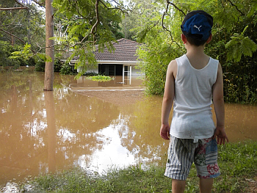
HELPING CHILDREN AFTER A DISASTER

A catastrophe such as a flood is frightening to children and adults alike. It is important to acknowledge the frightening parts of the disaster when talking with a child about it. Falsely minimizing the danger will not end a child's concerns. Several factors affect a child's response to disaster.

The way children see and understand their parents' response is very important. Children are aware of their parents' worries most of the time but they are particularly sensitive during a crisis. Parents should admit their concerns to their children, and also stress their abilities to cope with the situation.

A child's reaction also depends on how much destruction he or she sees during and after the disaster. If a friend or family member has been killed or seriously injured, or if the child's school or home has been severely damaged, there is a greater chance that the child will experience difficulties.

A child's age affects how the child will respond to the disaster. For example, six-year-olds may show their concerns about a catastrophe by refusing to attend school, whereas adolescents may minimize their concerns but argue more with parents and show a decline in school performance. It is important to explain the event in words the child can understand.

Following a disaster, people may develop Post-Traumatic Stress Disorder (PTSD), which is psychological damage that can result from experiencing, witnessing or participating in an overwhelmingly traumatic (frightening) event.

Children with this disorder have repeated episodes in which they re-experience the traumatic event. Children often relive the trauma through repetitive play.

In young children, distressing dreams of the traumatic event may change into nightmares of monsters, of rescuing others or of threats to self or others.

PTSD rarely appears during the trauma itself. Though its symptoms can occur soon after the event, the disorder often surfaces several months or even years later.
Parents should be alert to these changes:

- Refusal to return to school and "clinging" behavior, shadowing the mother or father around the house;
- Persistent fears related to the catastrophe (such as fears about being permanently separated from parents);
- Sleep disturbances such as nightmares, screaming during sleep and bedwetting, persisting more than several days after the event;
- Loss of concentration and irritability;
- Behavior problems - for example, misbehaving in school or at home in ways that are not typical for the child;
- Physical complaints (stomachaches, headaches, dizziness) for which a physical cause cannot be found;
- Withdrawal from family and friends, listlessness, decreased activity, preoccupation with the events of the disaster.

Professional advice or treatment for children affected by a disaster—especially those who have witnessed destruction, injury or death—can help prevent or minimize PTSD.

Parents who are concerned about their children can ask their pediatrician or family doctor or contact Mental Health America of Greater Houston’s partner, United Way of Greater Houston for help identifying a mental health professional.

For help, information, or referrals,

Dial 2-1-1

211 HELPLINE at United Way
2-1-1 is the number to call when you don't know who to call. Trained HELPLINE specialists are good listeners, blending understanding and expertise to provide information and referrals drawn from a comprehensive database of social services.


Mental Health America of Greater Houston, the area’s longest-serving mental health education and advocacy organization, has been a proud United Way Agency shaping and responding to the mental health needs of communities and all people since 1958.
www.mhahouston.org

